Device tree , reverse engineering for raspberry pi 3

The device tree sources for the raspberry pi 3 are:

bcm2710-rpi-3-b.dts
bcm2710-rpi-cm3.dts

The sources for those two device tree files are located at:
output/build/linux-5e4ee836560d4c0371e109bf469e1ad808ae7a44/arch/arm/boot/dts

it can be found after buildroot downloaded and extract the rasp pi 3 kernel.

We will focus on the relationship between the device tree files to the drivers that should use the defenitions inside.
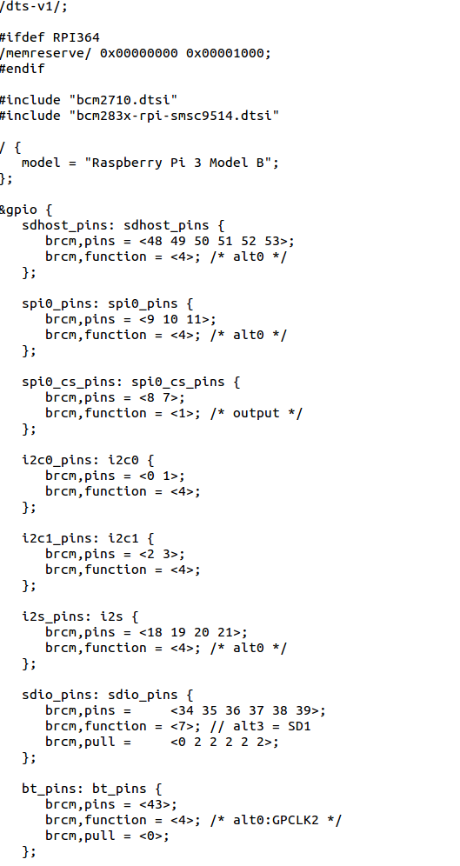
A brief look at the bcm2710-rpi-3-b.dts

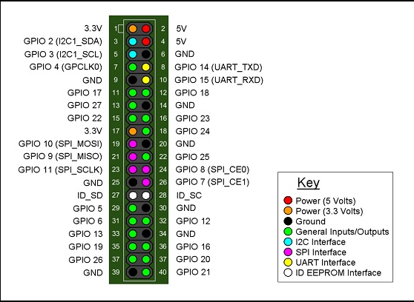

The bcm2710-rpi-30b.dts start with:
/dts-v1/;

but it already include two additional files:

#include "bcm2710.dtsi"
#include "bcm283x-rpi-smsc9514.dtsi"

Going through the bcm2710.dtsi

compatible = "brcm,bcm2837", "brcm,bcm2836";

compatible specifies the name of the system. It contains a string in the form "<manufacturer>,<model>

node name:
soc

'Cells' are 32 bit unsigned integers delimited by angle brackets:

